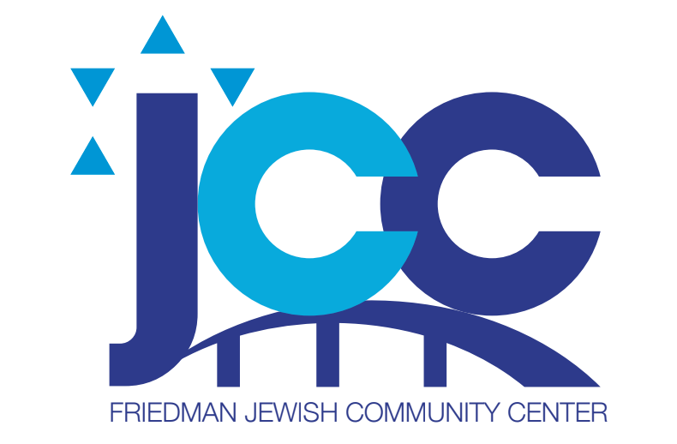
AUGUST 2022 Menu Friedman JCC
Monday, August 1 Baked Breaded Fish, Rice Pilaf, Lettuce, Tomato, Cuc Salad, Dressing, Fruit
Tuesday, August 2 Blintzes with Fruit Topping, Sour Cream, Carrots, Fruit
Wednesday, August 3 Roasted Chicken, Potato Pancake, String Beans, Applesauce, Fruit
Thursday, August 4 Hamburger on a Bun, Lettuce Tomato, Corn Salad, Plain Potato Chips Fruit
Friday, August 5 Tuna Salad Wrap, Tomato and Lettuce, Chips, Fruit
Monday, August 8 Cheese and Vegetable Lasagna, Broccoli, Cauliflower, Carrot Medley, Fruit
Tuesday, August 9 Penne Bolognese, Peas and Carrots, Fruit
Wednesday, August 10 BBQ Chicken, Baked Potato, Zucchini, Cole Slaw, Fruit
Thursday, August 11 Fresh Baked Tilapia, Yellow Rice, String Beans, Fruit
Friday, August 12 Egg Salad on a Roll, Lettuce, Tomato, Potato Chips, Fruit
Monday, August 15 Pasta Primavera, Salad with Lettuce and Tomato, Dressing, Fruit
Tuesday, August 16 Meat Loaf, Mashed Potatoes, Gravy, Mixed Vegetables, Fruit
Wednesday, August 17, Lemon Chicken, Baked Sweet Potato, String Beans, Fruit
Thursday, August 18 Eggplant Parmesan, Pasta with Sauce, Mixed Vegetables, Fruit
Friday August 19, Scoop of Tuna Fish Salad on Bed of Lettuce, Tomato and Cucumber, Dressing, Crackers, Chips, Fruit
Monday, August 22 Baked Ziti with Cheese and Sauce, Lettuce and Tomato Salad, Dressing, Fruit
Tuesday August 23 Chicken Club Sandwich on Toast, with Lettuce, Tomato, and Mayo, Carrot and Celery Sticks, Potato Chips, Fruit
Wednesday, August 24 Roasted Chicken, Whipped Potatoes, Peas and Carrots, Fruit
Thursday August 25, Plain Bagel, Cream Cheese, Lox, Lettuce, Tomato, Chips, and Fruit
Friday, August 26 2 Slices of Pizza, Tossed Salad, Dressing. Fruit
Monday, August 29 Chili Con Carne over Pasta, Lettuce, Tomato, Cuc Salad, Dressing, Fruit
Tuesday August 30 Baked Tilapia, Buttered Noodles, Red Beet Salad, Fruit
Wednesday, August 31 Roasted Chicken, Mashed Potatoes, Peas and Carrots, Fruit

RESERATIONS MUST BE MADE 1 WEEK IN ADVANCE!!!!!!

