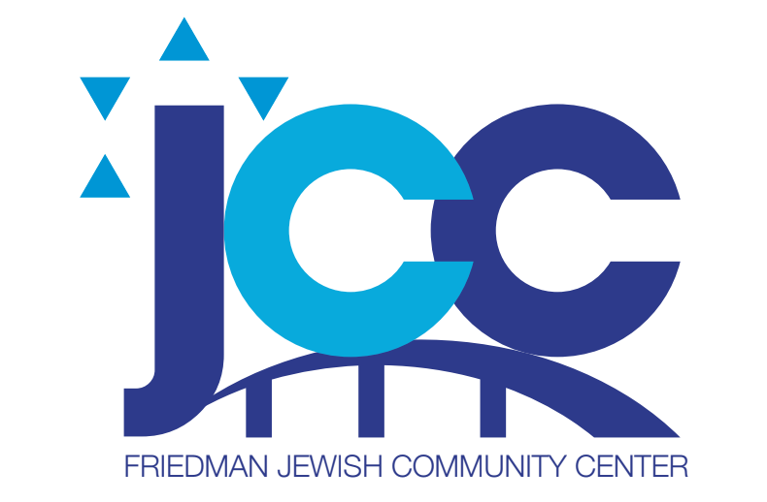

October Menu 2022 Menu Friedman JCC
Monday, October 3 Hamburger on a Bun, Lettuce Tomato, Corn Salad, Peas and Carrots, Fruit
Tuesday October 4 NO LUNCH Kingston Kosher closed Kol Nidre
Wednesday, October 5 NO LUNCH YOM KIPPUR
Thursday, October 6 Roasted Chicken, Potato Pancake, String Beans, Applesauce, Fruit
Friday October 7 Baked Breaded Fish, Rice Pilaf, Lettuce, Tomato, Cuc Salad, Dressing, Fruit
Monday, October 10 NO LUNCH Sukkot
Tuesday October 11 NO LUNCH Sukkot
Wednesday October 12 NO LUNCH Kingston Kosher Closed
Thursday, October 13 NO LUNCH -Kingston Kosher Closed
Friday October 14 NO LUNCH _Kingston Kosher Closed
Monday, October 17 NO LUNCH Shemini Atzeret
Tuesday, October 18 NO LUNCH Simchat Torah
Wednesday October 19 Lemon Chicken, Whipped Potatoes, Peas and Carrots, Fruit
Thursday October 20 Plain Bagel, Cream Cheese, Lox, Lettuce, Sliced Tomato, Chips, and Fruit
Friday, October 21 2 Slices of Pizza, Tossed Salad with Lettuce Tomato and Cucumber, Dressing. Fruit
Monday, October 24 Chili Con Carne over Pasta, Lettuce, Tomato, Cuc Salad, Dressing, Fruit
Tuesday October 25 Baked Tilapia, Buttered Noodles, Red Beet Salad, Fruit
Wednesday, October 26 Bar B Q Chicken, Roasted Potatoes, Broccoli and Cauliflower Medley, Fruit
Thursday, October 27 Pasta with Meat Sauce, Salad Lettuce, Tomato, Cucumber, Dressing, Slice of Italian Bread Fruit
Friday, October 28 Tuna Salad on Rye Bread, Tomato and Lettuce, Carrot and Celery Sticks Chips, Fruit
Monday, October 31 2 Blintzes Cherry Topping, Sour Cream, Carrots, Fruit
RESERVATIONS MUST BE MADE 1 WEEK IN ADVANCE!!!!
Call the Front Desk 570824-4646!!

