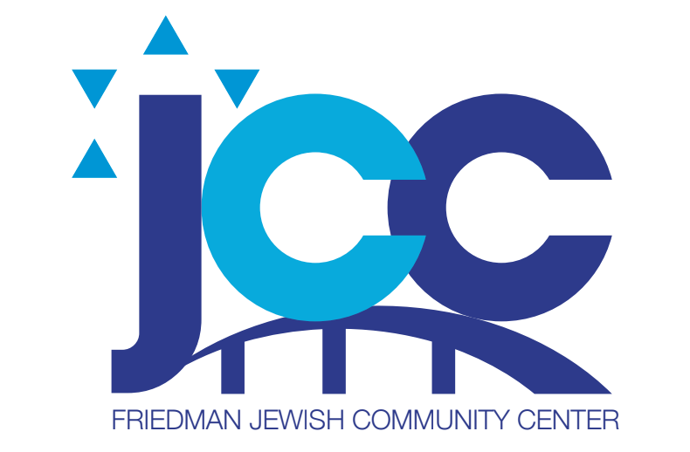
November 2022 Menu Friedman JCC

Tuesday, November 1 Chef Salad Romaine Lettuce, Chicken, Tomatoes, Cucumbers, Carrots, Hard Boiled Egg, Dressing, Roll, Special Dessert
Wednesday, November 2 Roasted Chicken, Potato Pancake, String Beans, Applesauce, Fruit
Thursday, November 3 Hamburger on a Bun, Lettuce, Tomato, Cole Slaw Chips, Fruit
Friday, November 4 Tuna Salad Wrap, Tomato and Lettuce, Chips, Fruit
Monday, November 7 Cheese and Lasagna with Sauce, Broccoli, Cauliflower, Carrot Medley, Fruit
Tuesday, November 8 Penne Bolognese, Peas and Carrots, Fruit
Wednesday, November 9 BBQ Chicken, Baked Potato, Zucchini, Cole Slaw, Fruit
Thursday, November 10 Fresh Baked Tilapia, Yellow Rice, String Beans, Fruit
Friday, November 11 No Lunch Veterans Day
Monday, November 14 Pasta Primavera, Salad with Lettuce and Tomato, Dressing, Fruit
Tuesday, November 15 Meat Loaf, Mashed Potatoes, Gravy, Mixed Vegetables, Fruit
Wednesday, November 16, BBQ Chicken, Baked Sweet Potato, Zucchini, Cole Slaw, Fruit
Thursday, November 17 Thanksgiving Lunch Turkey, Gravy, Mashed Potatoes, Stuffing, String Beans, Cranberry Sauce Roll, Pie
Friday November 18, Scoop of Tuna Fish Salad on Bed of Lettuce, Tomato and Cucumber, Dressing, Crackers, Chips, Fruit
Monday, November 21 Baked Ziti with Cheese and Sauce, Lettuce and Tomato Salad, Dressing, Fruit
Tuesday November 22 Chicken Club Sandwich on Toast, with Lettuce, Tomato, Bacon, and Mayo, Carrot and Celery Sticks, Potato Chips, Fruit
Wednesday, November 23 Roasted Chicken, Whipped Potatoes, Peas and Carrots, Fruit
Thursday November 24Thanksgiving NO LUNCH
Friday, November 25 No LUNCH
Monday, November 28 Plain Bagel, Cream Cheese, Lox, Lettuce, Tomato, Chips and Fruit
Tuesday, November 29 Baked Tilapia, Buttered Noodles, Red Beet Salad, Fruit
Wednesday, November 30 Lemon Chicken, Roasted Potatoes, String Beans, Fruit

RESERVATIONS MUST BE MADE 1 WEEK IN ADVANCE!!!!!!

